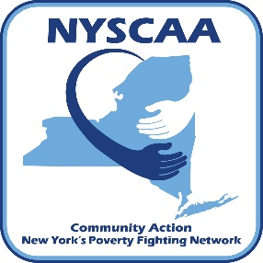

ACE Interface Master Trainer Application
Short Text Response Questions

Once you have filled out and saved this document, please fill out the online application. You will be asked to upload this document as part of this online application.
You can find the online Application at:
https://nyscaa.online/ace-interface-master-trainer-application/

------------------------------------------------------------------------------------------------------------------------------------
Please include a short (1- 5 sentence) response for each question.

- Are you a certified trainer in another area. If so, when and why did you become certified? (i.e., ROMA, FDC, etc?)

- Please describe any local/regional/national training you have done.

- What interests you about becoming a NEAR Expert Presenter & Coach?

- Please explain how you believe you would use this training.

- Being a NEAR Expert Presenter & Coach is a significant commitment, particularly during the certification process. Please describe how this would work within your existing schedule/commitments; please include whether or not your supervisor has agreed to allow you release time for this activity (if relevant).

- Which communities or audiences do you feel you are most able to reach into with the NEAR science information – why is this reach important?

- Please briefly describe how you would engage a given audience or community. What strategies would use? Please include example(s) of strategies that you have found successful in the past.

- Talking about trauma and adversity can be emotionally challenging for trainers and audience members. It is primarily important that a speaker/trainer know his/her own triggers and emotional responses and has a plan to manage responses during a challenging conversation. Please give an example of strategies you have found useful in the past.

- Is there anything else we should know about you that you think might be helpful?

